Step 1: Adding CSV and PDF files to the Document Store on the Flowise
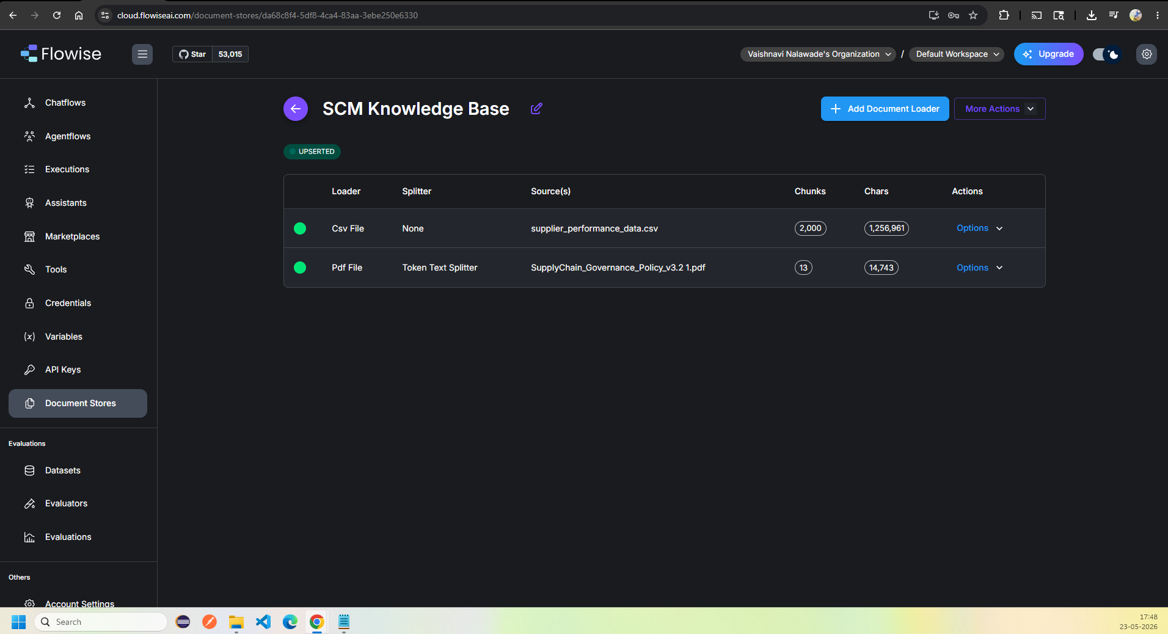

Step 2: Upload the CSV Files with no Text Splitter
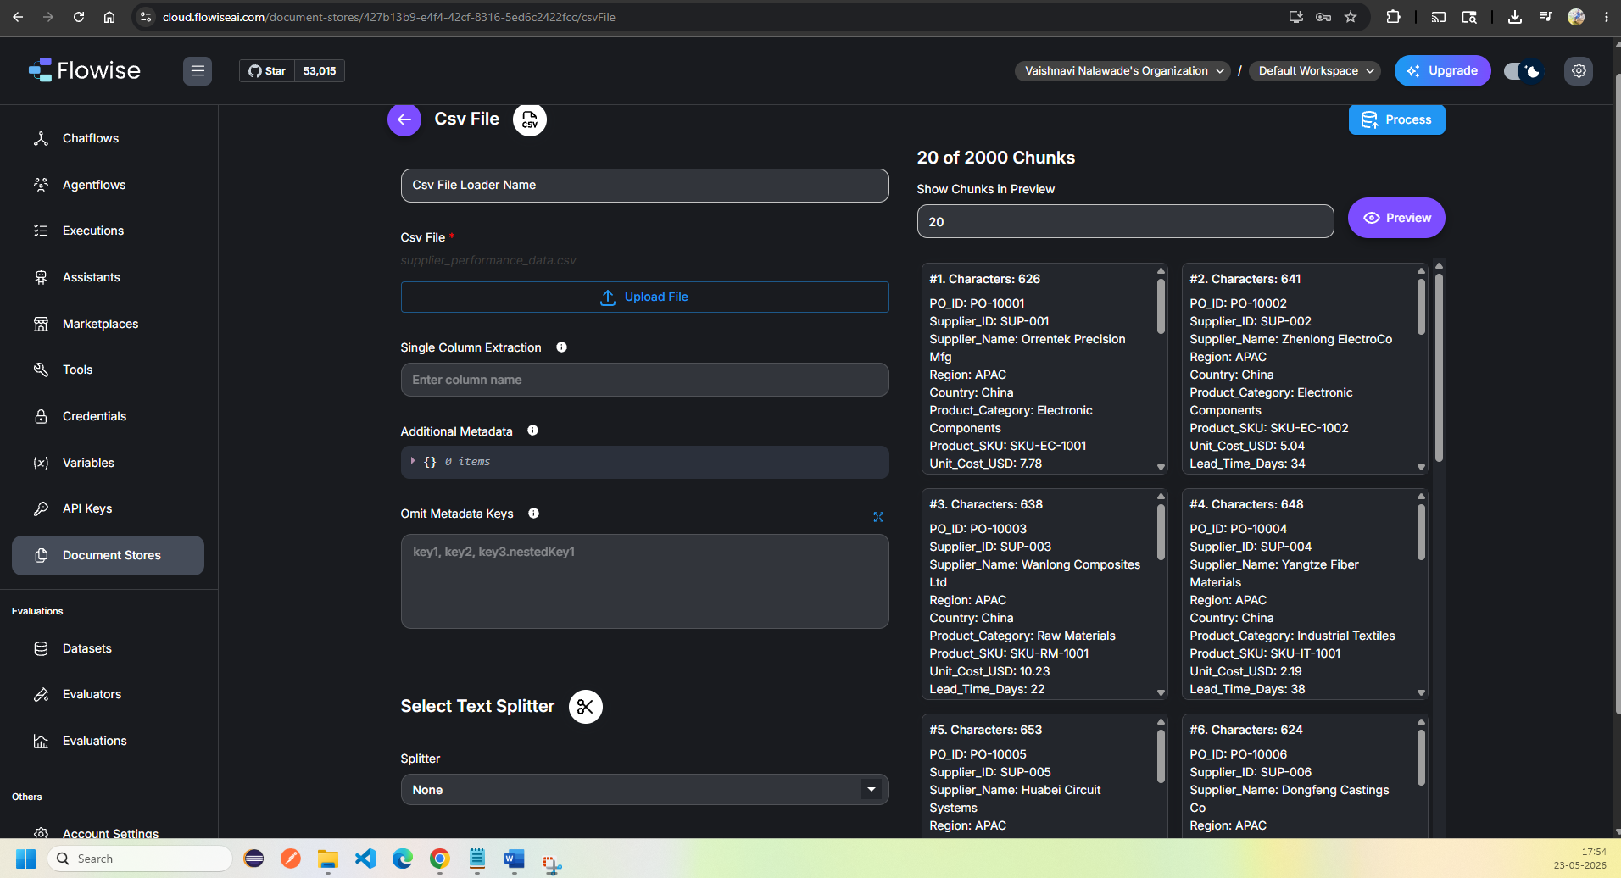

Step 3: Upload the pdf file with Token text Splitter and 500 Size chunk with 80 overlap chunks
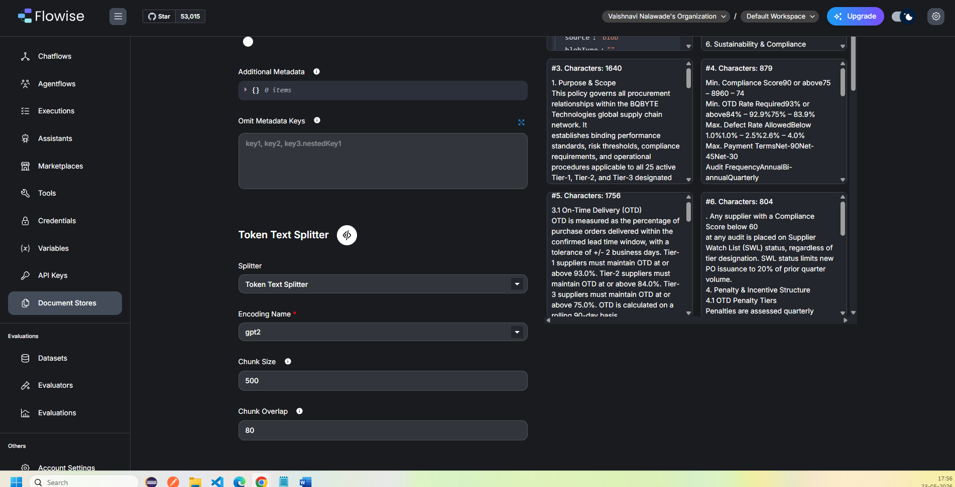

Step 4: Upsert the Documents
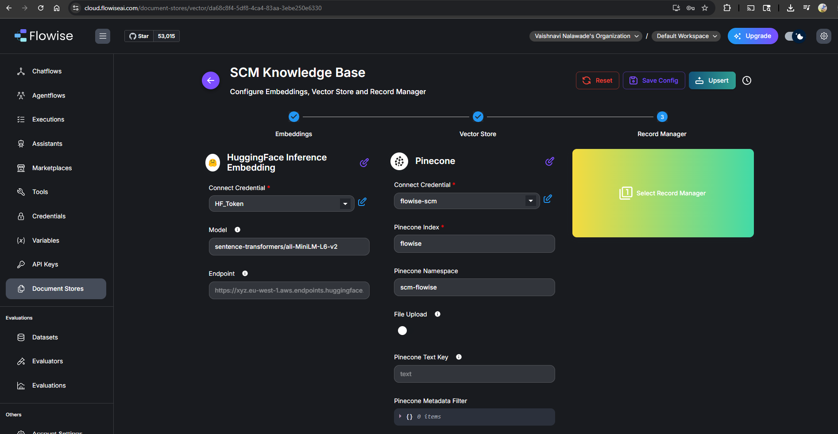

Step 6: Adding Hugging Face embedding API
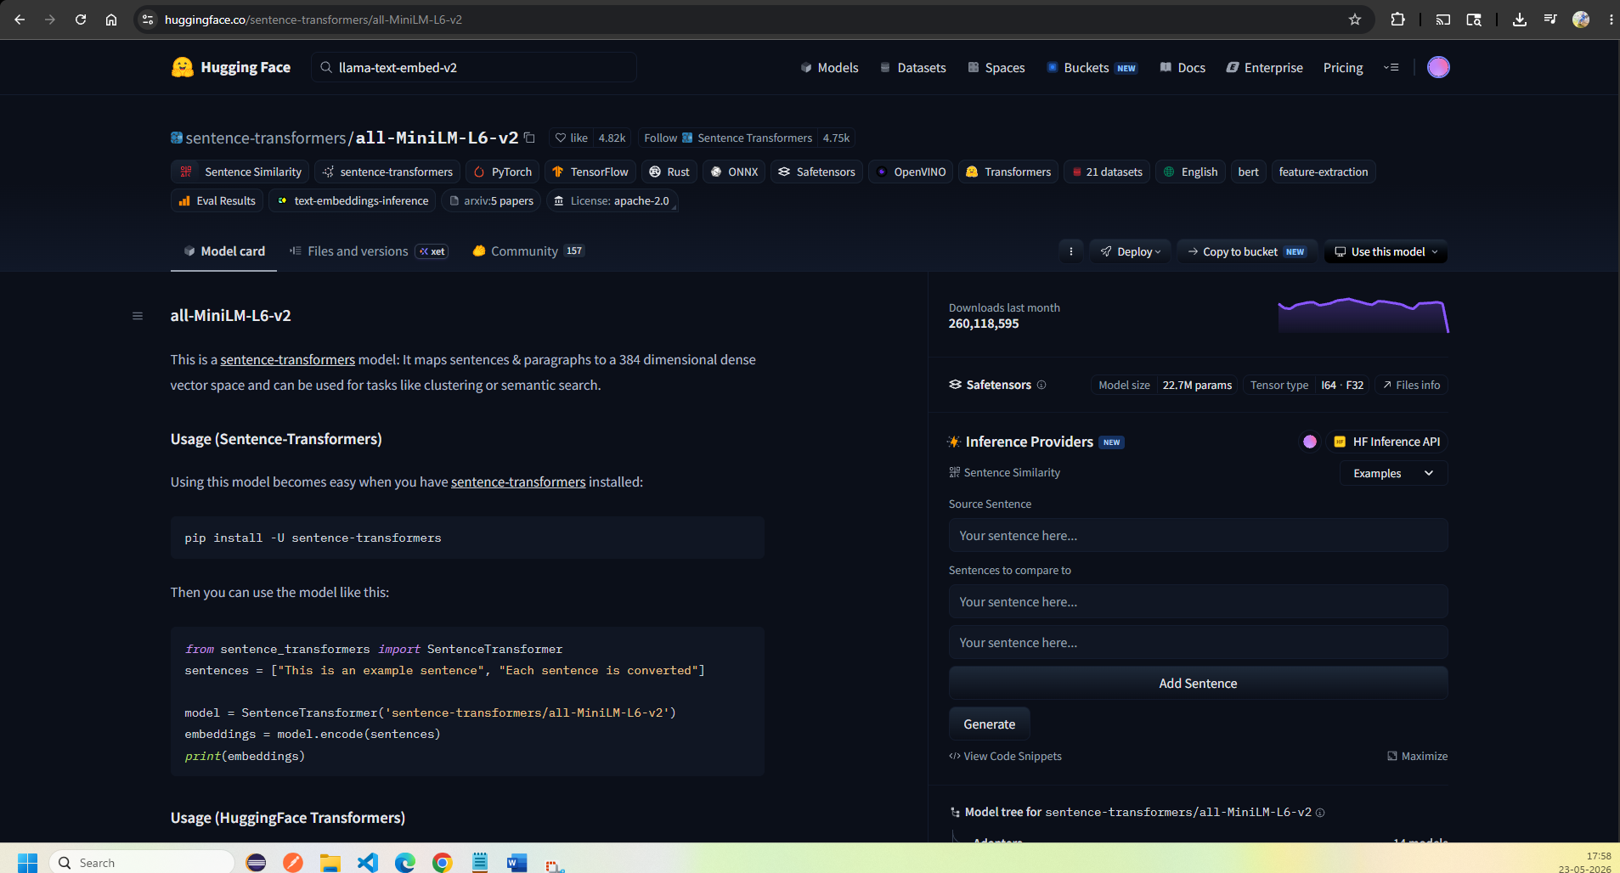

Step 7: Add Index in Pinecone
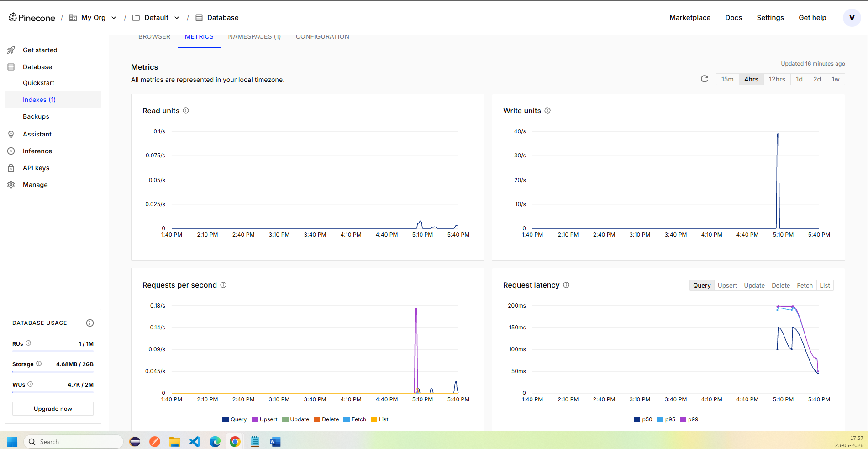

Step 8: ChatFlow
